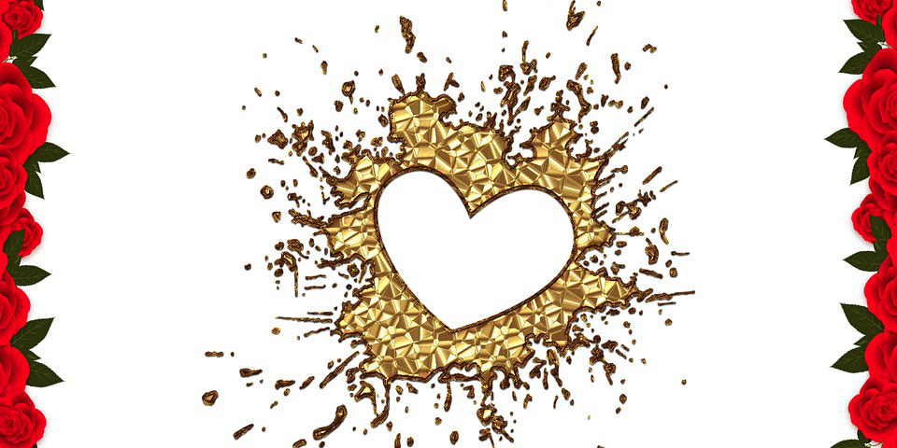

Divine Life is the Reconnecting of true Power to the Source of Divine Power Lines

It is based on an Integrated Life that comes to be from knowing its Creator and allowing that Source to form a whole new self with a regenerated mind through an intimate relationship with I Am. I am is the first narrative of ‘you’ that becomes connected with a stable new mind, body and spirit in harmony with all aspects of self. It transcends the old human way of thinking using divisions and separate aspects of self and others that form schisms within and get projected out to the external world and its contents.

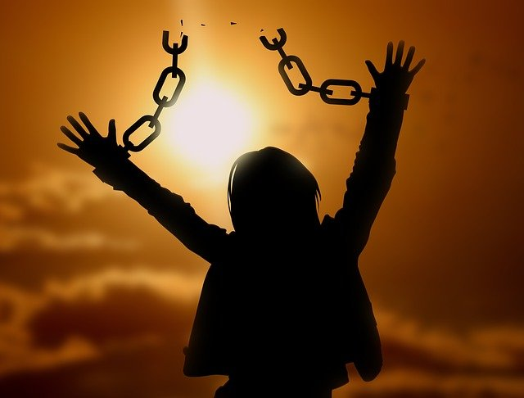
It is a process that is new daily and is gained through introspection and seeking help from within to grow from the seeds of spirit potential. Simply using human knowledge is limited by the outer world with its distractions and confusing opinions full of disconnected noise and faulty influences. The inner world of the spirit is quiet, reflective and meditative and finds its truth from higher aspects of its divinity. The inner world is a world seeking to find peace within that is not dependent on others. It is based on wisdom and love that transcends the human foundations.

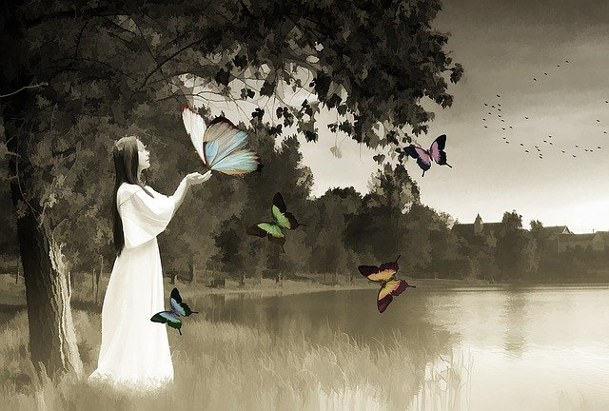

All Human minds are split and double as they are in parts or aspects that are combating each other. The conflict within all human nervous systems is based on animal natures that automatically react from fight or flight. Humans do that same behavior model but the difference is that humans are not created to merely survive. Humans are designed to rise above animal instincts and find connections with God, self and others so they can thrive and take dominion (self sovereignty). Humans are equipped with a potential baseline automatic program that is connected to a higher mind and smart brain that is like a computer that can make rational and reasonable decisions. That mind is connected to the human spirit and cannot be severed. Humans are given the choice to turn away from its power. This is a choice of their free will and it keeps them free to keep experiencing and learning from their trials and erroneous thinking patterns if they choose those.

Training, learning for human children without the influence of the Spirit of God will be full of information and mirroring based on the society and adults they were raised in and will still be under the influence of more programming even when taught to think critically. In addition, the programs of religious, political, educational, business, and all societal or cultural programs will influence the human brain. Currently, most humans are using a linear or double mind that is full of programs that are full of false constructs. This is often confusing to children bred under its captivity and gives rises to mixed or separated/divisive messages. Those messages are locked into the brain and its nervous systems full of energy that carries repressed emotions that were filed in their raw forms.

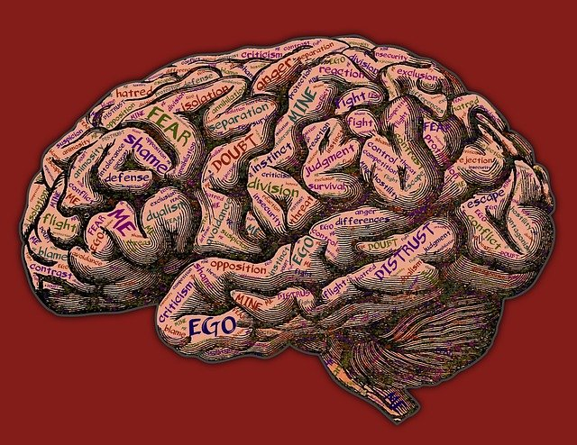

The integrated mind has taken the journey that goes within to connect to true self in three aspects using the mind, body and spirit located within each human. These areas get turned on and connected to the corresponding aspects of the Highest Best self-image as made in the image of The Creator of all that is real and forms everything. Through seeking and joining with those Divine Power Lines, a new self-image and world view appears fully connected to the Source or Spirit of God using a voice that speaks with a personal influence to each of its children. Some people refer to this as Supernatural Intelligence or Consciousness or the God of all creation. Those who seek this God through the spiritual realm do tap into its Presence through an inner knowing. New bonding happens and our being shifts over and over as it unfolds with the new light radiating truth and Perfect love.

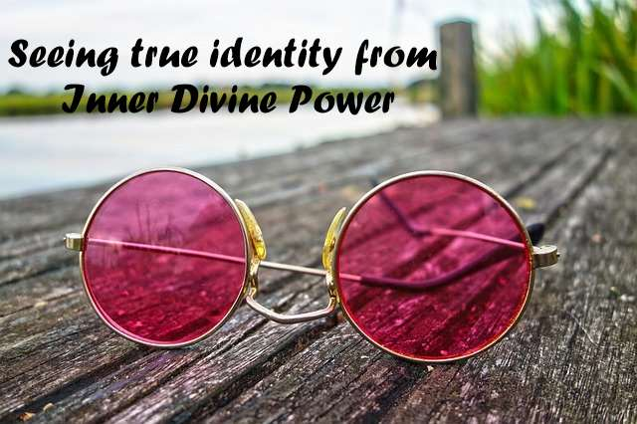

Imagine it this way. Humans are three part beings : mind, body and spirit. At their highest best point, they are still that in form. Seeking that Highest, Best Source is a journey and like any journey taken, it needs a good Guide. The Spirit of God is the Guide. This Guide has a system that is analogous to a View…like humans use a worldview. The worldview God uses is called His Kingdom or the Kingdom of God and is located in potential energy in all that is. We can see it in nature as things unfold as they are meant to be. Examples might be the butterfly and its stages of metamorphosis or any animal that goes from its baby form to its adult creature. It changes and grows and develops. Imagine yourself to be that way. YOU begin as a baby, learn and are trained as a ‘kid’ and begin to shape habits and thought patterns as you grow.

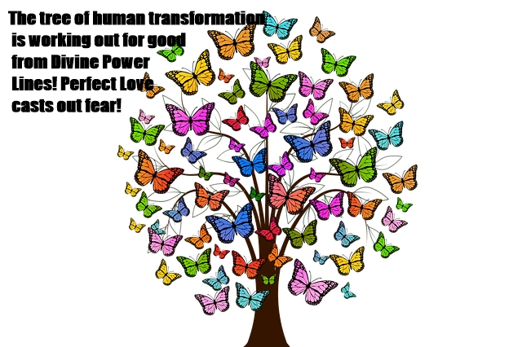

When a human stops growing physically and only matures his mind (or, not) with the world and its constructs and concepts, even knowledge gained will continue to be under interpretation of those old systems and trainings of mind and body as though they were separated from God even though that is an illusion. All teaching and study is still coming from the minds and thoughts or feelings of other humans. The human program is heavily influenced by its ego thinking patterns.
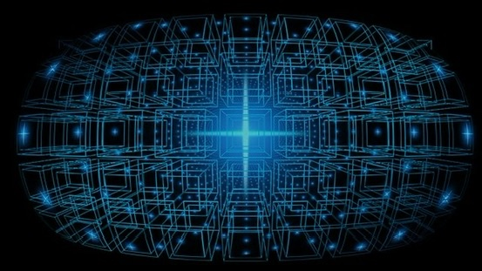

Knowing God, therefore, must be personal, intimate and have an inner voice that is integrated under that influence. It is something that is like a partnership. It needs to be sought after and connected until it has a firm trust to be anchored from within that knows it exists without a doubt. Sound impossible? It would be without a super plan of God to reveal Himself in everything once this awakening, awareness and connection had not been planned from the beginning. The light of God is in everyone and is called His Spirit. It illuminates the mind and body to ascend above the programs and to know things it could not know if it were separated or thought from parts of a split self in combat or conflict with itself.

The Spirit man is connected through the Spiritual realm from a top down process. All energy gets divinely converted in thought formation, with emotions opening hearts to compassion over anger and judgment, and take on a new body that is regenerating from the new mind and how it feels about its identity as made in the image of God. All of these aspects begin to balance and harmonize when relationships are seen from grace and love as described by God with the way of unconditional love. Source Love is perfect and is ready to cast our all fear senses.

This love must come through inspiration that overcomes fear and guilt and finger pointing at each other. This way of love endures and is patient, kind, not envious, nor boiling over with jealousy, pride, or arrogance. It is not rude and act against self and others. It is not anxious or fretful with worry as its leader. The way of love does not keep records of wrong or rejoice over injustice and unrighteousness since it is able to bear and prevail until it does become whole, integrated and holy as the One mind that knows it is precious, formed by God and can nothing can change that form or separate it from anything.

This mind and spirit is accelerated by faith connected from new thoughts that know and imagine upon things true, honest, just, pure, lovely, of good report, and praise all that God gives and sees it as a blessing. Once mankind partners with God, the mind, body and spirit of God expresses through that soul and comes out of the old ways of pain and suffering into healing and wholeness that keeps unfolding through the perfection of the Source of all energy and creation. This Source is infinite and eternally regenerating its best aim for us as its progeny.

